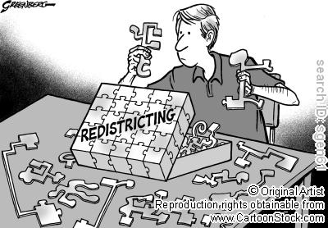
Besides seats, GOP Wins Sway in

2010 Redistricting
By MIKE BAKER, Associated Press Mike Baker, Associated Press – Sun Nov 7, 2010
RALEIGH, N.C. – Republicans don't just control much of the electoral map. In some cases, they now have the power to redraw it.
Overwhelming victories in statehouses and governors' races across the country this week have placed the GOP in command of redrawing both congressional and legislative districts to conform with Census results. It's a grueling and politically charged process that typically gives the party in power an inherent advantage for a decade, allowing them to preserve current strongholds or to put others in play.
Tim Storey, a redistricting expert at the National Conference of State Legislatures, estimates that Republicans will have unilateral control over the redrawing of 195 congressional districts. Democrats have just 45. The remainder are in states where either both parties have a chance to influence redistricting or where decisions will be made by independent commissions.
That doesn't mean there will be another surge of Republicans two years from now. After all, parties still must adhere to a substantial series of legal limitations governing the composition of the districts, such as making sure districts have a similar number of voters and are compact and contiguous.
And while redistricting has more recently become a refined science, Democrats can find at least some hope in looking at their own history: They had a redistricting advantage 20 years ago and then were hastily swept out of congressional power in 1994.
Census data provided by the end of this year will determine whether a state has gained or lost population, which is used to determine the number of congressional seats that a state gets.
States will then get detailed Census data in early 2011 to help them divvy up legislative districts. States that gain or lose seats often get the most attention.
A political consulting firm that specializes in redistricting, Election Data Services Inc., projects that eight states will gain seats with the new Census numbers. Texas would get four. Florida would get two. Arizona, Georgia, Nevada, South Carolina, Utah and Washington would each get one.
EDS projects that 10 states will lose seats. New York and Ohio stand to each lose two. States that face the prospect of losing a seat include Illinois, Iowa, Louisiana, Massachusetts, Michigan, Missouri, New Jersey and Pennsylvania.
Some states give independent commissions power to draw the boundaries, but it is largely a politically charged process. Of those 18 states that will apparently be forced to redraw maps, Republicans will now control governorships in 13 of them, with election gains this week in Florida, Iowa, Michigan, Ohio and Pennsylvania.
"Even in a state where you don't gain or lose, you still have to redraw the lines," Storey said. "Once you open up Pandora's box, anything can happen. It could be just as rough and tumble in a state that has the same number than a state that gains or loses."

- Why does the author suddenly think Republicans have so much power over the redrawing of districts?

- What are two limitations that legislators have when drawing the districts?

- According to Census estimates, how many seats will Texas add? How many will Florida add?

- Which states will probably add one more seat?

- Which states may lose two seats?

- Which states may lose one seat?

- What happens in states that don’t gain or lose a seat?

